IoT-Based Container Tracking Management
End-to-End Container Visibility, Security & Condition Intelligence
SATCAM proposition
Create a connected digital layer for container logistics by combining IoT-enabled container tracking, GPS, geofencing, door and condition sensors, vehicle/edge connectivity, Body-Worn Cameras, event-driven alerts and centralized operational evidence.

Introduction
Container logistics involves high-value cargo, distributed yards, ports, terminals, trucks, rail movements and multiple handovers. The challenge is not simply knowing where a container is; it is maintaining continuous visibility of the container, its movement, condition, custody events and supporting evidence from gate-in through transit, terminal handling and final delivery. | 
Business Context
Business Requirement | Operational Need
End-to-end container visibility | Know container location, movement status and journey milestones across road, rail, yard and terminal operations.
Cargo security | Detect unauthorized opening, unexpected movement, route deviation or prolonged stationary conditions.
Condition monitoring | Monitor selected parameters such as temperature, humidity, shock/impact or light exposure where applicable.
Yard & terminal management | Improve visibility of container dwell, movement, gate events and operational status.
Fleet / transport coordination | Associate containers with vehicles, trips, drivers and routes.
Handover accountability | Create a digital record of gate-in, gate-out, loading, unloading and custody-transfer events.
Operational supervision | Give control-room and logistics teams a consolidated view of containers, vehicles, locations and exceptions.
The Challenge
- Container status and location can become fragmented across shipping, terminal, fleet and manual tracking systems.
- Limited objective evidence of container handovers, loading/unloading and physical condition.
- Unexpected movement, unauthorized access, route deviation or extended dwell may not be identified quickly.
- Connectivity can be intermittent during remote transit, yards, terminals or cross-border journeys.
- Difficulty correlating container identity, vehicle, driver, route, location, sensor events and visual evidence.
- Manual reconciliation of tracking, gate events, inspection records and exception reports can delay operational response.

The SATCAM IoT-Based Solution
SATCAM creates an intelligent tracking, field-operations and evidence layer around existing container-management processes. IoT devices can provide container identity, location and selected condition/security information, while vehicle/edge gateways aggregate movement and telemetry data. Body-Worn Cameras provide visual evidence during inspections and handovers. Secure connectivity supports live visibility where available, with local buffering and synchronization for connectivity gaps.
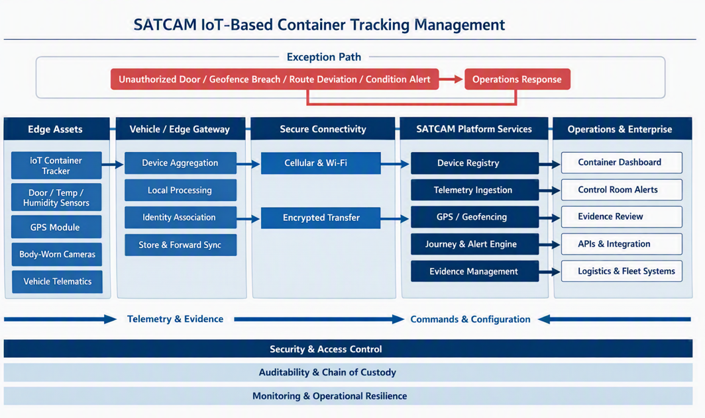
Figure 1. SATCAM IoT-Based Container Tracking Management solution architecture
A. Continuous Container Visibility
Associate each container with its location, journey, vehicle/trip, movement status and operational milestones. GPS and connectivity capabilities can provide live or periodic tracking according to the deployment model.
B. Container Security & Exception Detection
Use configured events such as unauthorized door opening, unexpected movement, geofence breach, route deviation, prolonged dwell or selected sensor thresholds to generate alerts for operational teams.
C. Condition & Cargo Environment Monitoring
For applicable cargo, IoT sensors can monitor selected environmental or physical parameters such as temperature, humidity, shock/impact, light exposure or door status. Thresholds can support exception management and intervention.
D. Digital Chain of Custody
Link container identity, location, vehicle, personnel, time, handover point and Body-Worn Camera evidence into an auditable operational record covering gate-in, handling, transit, delivery and gate-out activities.
E. Resilient Edge & Evidence Management
Where network connectivity is unavailable, relevant telemetry and evidence can be buffered locally and synchronized when connectivity is restored. Configured validation and controlled retention can support authorized operational and investigative review.
Typical Container Journey
One container. One connected journey
Stage | Operational Scenario
01 Container Registration | Container and IoT tracking device are linked to shipment, asset or logistics records.
02 Gate / Yard Entry | Gate event, container condition and relevant visual evidence are captured.
03 Loading & Dispatch | Containers are associated with vehicles, trips, route and responsible personnel.
04 In-Transit Tracking | GPS and selected sensor data provide location and journey status.
05 Exception Detection | Door opening, unexpected movement, route deviation, geofence breach, prolonged dwell or sensor threshold can trigger attention.
06 Control-Room Response | Operations team receives contextual alert and coordinates intervention.
07 Delivery & Handover | Container arrival, inspection, unloading and custody-transfer evidence are recorded.
08 Digital Closure | Journey history, IoT events and supporting video/evidence are synchronized and retained.

Reference Technology Architecture
Layer | Capability | Purpose
Container Layer | IoT Tracking Device / Sensors | Container identity, GPS and selected security/condition data.
Vehicle / Edge Layer | Gateway / Telematics Integration | Aggregate container, vehicle and trip telemetry; local buffering and connectivity.
Location Layer | GPS / GIS / Geofencing | Journey visibility, route and zone context.
Field Evidence | Body-Worn Cameras | Visual evidence for inspection, loading/unloading, handover and incidents.
Connectivity | Cellular / Wi-Fi / Available Networks | Live data transfer where available; store-and-forward resilience.
Intelligence | Rules / Event & Alert Engine | Security, dwell, route and condition exception detection.
Operations | Container Control Dashboard | Unified visibility of containers, vehicles, journeys and exceptions.
Enterprise | TMS / WMS / Terminal / ERP / Evidence | Integration with existing logistics, warehouse, terminal and records systems.

Key Operational Scenarios
- Road-based container tracking and fleet coordination
- Port, terminal and inland container depot visibility
- Container yard movement and dwell monitoring
- High-value or sensitive cargo security
- Reefer / temperature-sensitive cargo monitoring where applicable
- Door-open / unauthorized access detection
- Route deviation and geofence monitoring
- Shock / impact and condition-event monitoring
- Digital inspection and handover evidence
- Exception management and post-incident investigation
Expected Business Outcomes
Outcome | Value to Logistics Operator
End-to-end visibility | Improved awareness of container location, movement, journey status and operational milestones.
Enhanced cargo security | Faster identification of configured unauthorized access, movement and route exceptions.
Condition intelligence | Early visibility of selected environmental or physical events that may affect cargo.
Stronger chain of custody | Digital linkage of container, vehicle, personnel, location, handover and evidence.
Reduced dwell uncertainty | Better visibility of stationary containers and operational delays.
Faster exception response | Contextual alerts help operations teams investigate and intervene sooner.
Evidence continuity | Operational evidence remains available through connectivity interruptions using local buffering and synchronization.
Scalable logistics IoT foundation | A common layer for container tracking, fleet telemetry, Body-Worn Video and enterprise integration.
Integration Opportunities
SATCAM can operate as an IoT tracking, field-intelligence and evidence layer around existing logistics and transportation systems. Integration opportunities may include:
- Transportation Management Systems (TMS)
- Warehouse Management Systems (WMS)
- Terminal Operating Systems (TOS)
- Enterprise Resource Planning (ERP) systems
- Fleet Management / vehicle telematics
- Port Community / logistics platforms
- GPS / GIS and route-management systems
- Security operations and command-and-control platforms
- Digital evidence and records management systems
SATCAM Solution Components
Component | Role
IoT Container Tracker | Container identity, location and selected security/condition telemetry.
Security / Condition Sensors | Door, temperature, humidity, shock, light or other configured parameters, where required.
Vehicle / Edge Gateway | Aggregate container and vehicle data; provide local processing and connectivity resilience.
GPS & Geofencing | Journey visibility, route monitoring and location-based event detection.
Body-Worn Cameras | Visual evidence for inspections, handling, handovers and incidents.
Secure Connectivity | Support live transfer where available and store-and-forward operation.
Event & Alert Engine | Correlate configured IoT, location and operational events and prioritize response.
Evidence Management | Controlled synchronization, integrity validation, retention and authorized review.
Operational Dashboard | Centralized view of containers, vehicles, locations, journeys and exceptions.
“Track the Container. Secure the Cargo. Prove the Journey.”

