Leveraging IoT for Traceability, Predictive Maintenance, Safety, and Workforce Well-being in the Mining Industry
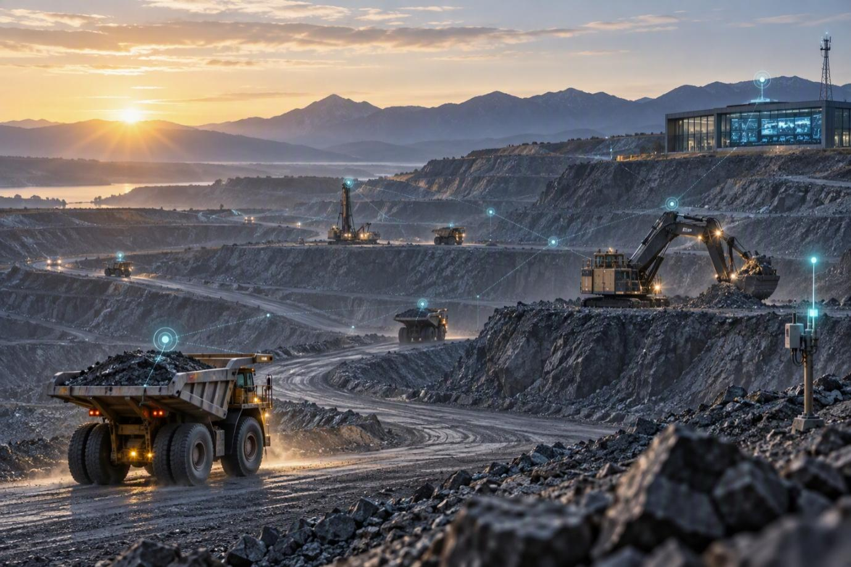
Executive Summary
The mining industry is undergoing a profound digital transformation driven by the need to improve operational efficiency, asset productivity, workforce safety, environmental sustainability, and profitability. As mines become larger, deeper, and more complex, traditional methods of asset tracking, equipment maintenance, and personnel management are proving inadequate to meet modern operational demands.
The Internet of Things (IoT) has emerged as a foundational technology for the digital mine, enabling real-time visibility of people, equipment, materials, and processes across the mining value chain. Through connected sensors, intelligent devices, wireless networks, data analytics, and AI-powered platforms, IoT transforms mines from reactive operations into intelligent, data-driven enterprises.
A modern mining IoT strategy should go beyond connectivity and point solutions. The greatest value is created when data from mobile equipment, fixed assets, workers, environmental sensors, video systems, drones, and operational applications is brought together through secure connectivity, edge computing, AI-driven analytics, and integrated command-and-control capabilities. This enables mining organizations to move from visibility to prediction, coordinated response, and increasingly autonomous decision-making while maintaining appropriate cybersecurity, data governance, and workforce privacy safeguards.
This white paper explores how IoT enables significant business value across four key areas:
Value area | Operational focus
Trace and Track | Assets, equipment, materials, and personnel
Predictive and Preventive Maintenance | Equipment health, failure prediction, and planned intervention
Safety and Risk Management | Collision avoidance, environmental monitoring, geofencing, and emergency response
Workforce Health and Well-being | Wearables, fatigue management, lone-worker protection, and responsible analytics

It also outlines a strategic roadmap for mining organizations seeking to implement an integrated IoT ecosystem.
Industry Context
Mining organizations face multiple operational challenges:
- Limited visibility of mobile assets and equipment
- Equipment failures causing production losses
- Safety risks in hazardous environments
- Increasing regulatory compliance requirements
- Rising maintenance costs
- Workforce shortages and productivity pressures
- Remote and geographically dispersed operations
According to leading digital transformation frameworks, mining companies must evolve from siloed operations toward connected, autonomous, and intelligent mining ecosystems.
The technology landscape is also expanding beyond basic asset tracking. AI-enabled video analytics, drones and robotics, digital twins, edge intelligence, private wireless networks, and integrated operations centres are increasingly important components of a connected mine. Their value depends on interoperability with existing Fleet Management Systems (FMS), Enterprise Asset Management (EAM), ERP, safety, environmental, and production systems.
IoT provides the digital foundation for this transition.
IoT in Mining: The Digital Nervous System of Operations
An IoT ecosystem in mining typically consists of:
Connected Devices
- Smart sensors
- Wearables
- GPS trackers
- Environmental sensors
- Industrial gateways
- Smart cameras
Connectivity Infrastructure
- Private LTE/5G
- Wi-Fi Mesh Networks
- LoRaWAN
- Satellite Communications
- Edge Computing Platforms
Digital Platforms
- Asset Management Systems
- Fleet Management Systems
- Operations Management Solutions
- AI and Analytics Platforms
- Digital Twin Environments
AI-enabled Video Intelligence
- Computer vision for PPE, intrusion, vehicle-person interaction, smoke/fire, and unsafe-condition detection
- Drone and robotic inspection data
Event and Integration Layer
- Event bus / middleware for real-time alerts, workflow orchestration, and system interoperability
Together, these technologies create a real-time operational view of the entire mining environment.
For geographically dispersed mines, the architecture should support edge processing and store-and-forward operation so that critical safety and equipment functions can continue during temporary network outages.
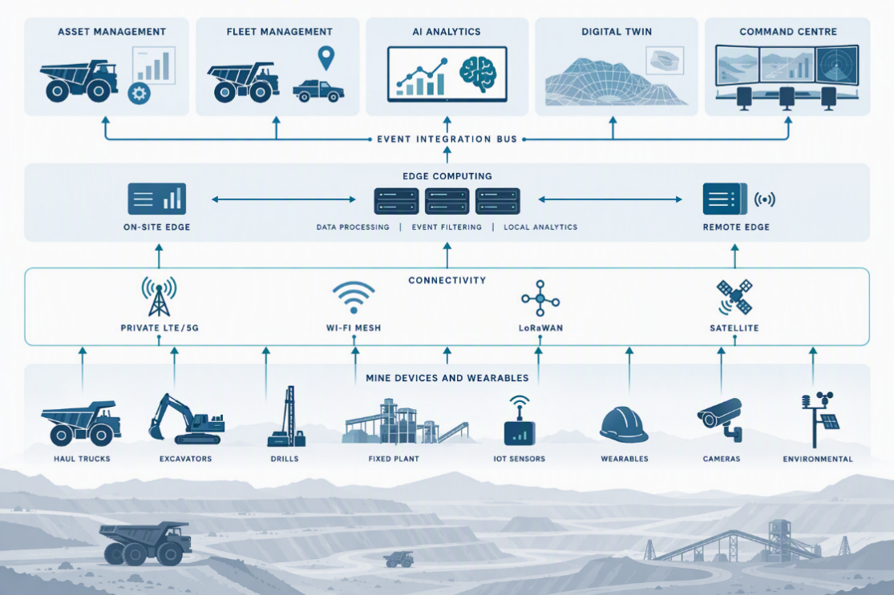
- Trace and Track: Building End-to-End Operational Visibility
  - Asset Tracking
Mining operations typically manage thousands of mobile and fixed assets including:
- Haul trucks
- Excavators
- Loaders
- Wagons
- Rail assets
- Containers
- Drilling equipment
- High-value tools
IoT-enabled GPS and sensor technologies provide real-time tracking of these assets. Where available, vehicle telemetry, CAN-bus data, payload information, fuel consumption, operating hours, and equipment health indicators can be correlated with location data to create a richer asset-intelligence layer rather than simple location tracking.
Benefits
- Real-time location visibility
- Reduced asset search time
- Improved fleet utilization
- Prevention of asset loss
- Reduced idle time
- Better dispatch efficiency
Business Impact
Mining companies can optimize fleet deployment and reduce unnecessary asset procurement by maximizing utilization of existing equipment.
  - Material Traceability
IoT enables tracking of material movement from pit to plant and shipment.
Organizations gain visibility into:
- Ore extraction location
- Haul routes
- Stockpile movements
- Processing stages
- Shipment destinations
Material identity, quality/grade, quantity, and custody events can also be associated with each movement to strengthen digital chain-of-custody and reconciliation.
Benefits
- Supply chain transparency
- Improved inventory control
- Chain-of-custody validation
- Better production planning
- Reduced material losses
  - Personnel Tracking
Worker tracking is becoming increasingly important in modern mines. IoT-enabled smart badges and wearable technologies can monitor:
- Employee location
- Zone entry and exit
- Muster management
- Emergency evacuation status
In higher-risk operations, connected wearables, panic/SOS devices, man-down detection, and location-enabled body-worn cameras can extend personnel tracking into incident response and digital evidence capture.
Benefits
- Improved accountability
- Faster emergency response
- Better workforce allocation
- Enhanced compliance management

- Predictive and Preventive Maintenance
The Challenge
Equipment downtime remains one of the largest contributors to production losses in mining.
Critical assets include:
- Haul trucks
- Crushers
- Conveyors
- Pumps
- Draglines
- Rail assets
- Processing equipment
Traditional maintenance approaches are often:
- Reactive (failure-based)
- Schedule-driven
- Manual inspection-intensive
These approaches increase costs and operational risks.
IoT-Enabled Predictive Maintenance
IoT sensors continuously monitor equipment health through:
Mechanical Parameters
- Vibration
- Shock
- Load stress
- Equipment utilization
Thermal Parameters
- Bearing temperature
- Engine temperature
- Hydraulic temperature
Performance Parameters
- Fuel consumption
- Pressure levels
- Cycle times
- Runtime hours
Condition Parameters
- Lubrication quality
- Wear indicators
- Structural integrity
Parameter group | Signals monitored
Mechanical | Vibration, shock, load stress, equipment utilization
Thermal | Bearing temperature, engine temperature, hydraulic temperature
Performance | Fuel consumption, pressure levels, cycle times, runtime hours
Condition | Lubrication quality, wear indicators, structural integrity

Predictive Analytics
AI and machine learning algorithms analyse sensor data to identify:
- Developing faults
- Failure patterns
- Equipment degradation
- Abnormal operating conditions
Maintenance teams receive alerts before equipment failures occur.
For critical assets, analytics can be deployed at the edge for low-latency detection, with confirmed events and historical data synchronized to the central platform. Predictive alerts should feed maintenance workflows in EAM/CMMS systems so that condition-based insights translate into work orders, parts planning, and maintenance scheduling.
Examples include:
- Bearing failure prediction, Hydraulic system degradation, Conveyor belt wear, Engine performance deterioration
Business Benefits
- Reduced Downtime
- Failures are detected before breakdowns occur.
- Lower Maintenance Cost
- Repairs are planned instead of performed under emergency conditions.
- Increased Equipment Availability
- Assets spend more time producing and less time undergoing repairs.
- Improved Asset Life
- Improved Maintenance Planning
  - Maintenance actions are based on actual condition rather than fixed schedules.
  - Condition-based insights help maintenance teams prioritize critical interventions, coordinate spares and manpower, and reduce avoidable preventive work.
- Safety and Risk Management
Mining Safety Challenges
Mining remains one of the world's most hazardous industries.
Common risks include:
- Vehicle collisions
- Ground instability
- Toxic gas exposure
- Fatigue-related incidents
- Confined space hazards
- Equipment failures
- Environmental incidents
IoT significantly strengthens operational safety. Safety is strengthened further when sensor data is correlated with AI video analytics, geofencing, equipment telemetry, environmental conditions, and worker location to create a common operating picture for safety teams.
  - Collision Avoidance
IoT sensors combined with GPS and proximity technologies can detect:
- Vehicle-to-vehicle proximity
- Vehicle-to-person interactions
- Blind-spot hazards
Real-time alerts help operators avoid collisions.
Depending on the technology and operating environment, systems may provide graded warnings, operator alerts, or integration with vehicle-control functions. Safety-critical automation should be validated against the mine's operating procedures and applicable regulatory requirements.
Benefits
- Reduced accidents
- Lower insurance costs
- Enhanced operational confidence
Environmental Monitoring
IoT environmental sensors continuously monitor:
- Dust levels
- Methane concentration
- Carbon monoxide
- Temperature
- Humidity
- Air quality
  - Visibility / dust-event conditions
Alerts can be generated immediately when thresholds are exceeded. Environmental events can also be correlated with workforce location and operating zones so that exposure can be assessed and response actions prioritized.
Benefits
- Faster incident response
- Improved compliance
- Reduced workforce exposure

Geofencing and Restricted Area Management
Virtual geofences can monitor access to:
- Blasting zones
- High-risk operating areas
- Maintenance zones
- Hazardous storage locations
Automatic notifications are generated when unauthorized entry occurs. Geofencing can also be linked to vehicle dispatch, worker alerts, video verification, and incident workflows to create a coordinated response rather than a stand-alone notification.
Emergency Response Management
During emergencies, IoT systems provide:
- Real-time worker location
- Muster verification
- Evacuation monitoring
- Personnel accountability
Leadership gains complete visibility during critical events.
An integrated incident-management workflow can preserve the event timeline, associated sensor/video evidence, actions taken, and closure status for post-incident analysis and compliance reporting.

- Workforce Health and Well-being
  - The Human-Centric Mining Enterprise
Progressive mining organizations recognize that safety extends beyond accident prevention.
Workforce well-being has become a strategic priority. IoT enables proactive employee health monitoring while improving workplace conditions.
  - Wearable Technology
Smart wearables can monitor:
- Heart rate
- Fatigue indicators
- Body temperature
- Physical exertion
- Location tracking
These devices help identify conditions that may lead to health or safety incidents.
Where physiological monitoring is used, organizations should define clear purpose, consent, access controls, retention periods, and data-governance practices so that worker well-being technology is used responsibly and does not become an uncontrolled source of personal surveillance.
  - Fatigue Management
Fatigue is a major contributor to mining accidents.
IoT-enabled systems can monitor:
- Shift duration
- Fatigue indicators
- Operator alertness
- Vehicle driving behaviour
Supervisors receive alerts when risk levels increase.
Benefits
- Fewer fatigue-related incidents
- Improved workforce performance
- Better worker health outcomes

  - Lone Worker Protection
Workers often operate in remote locations.
IoT devices provide:
- Continuous monitoring
- Panic alarms
- Man-down detection
- Automatic incident notifications
  - Two-way voice / push-to-talk or emergency communication
This significantly improves employee confidence and response times.
  - Well-being Analytics
Organizations can leverage aggregated data to improve:
- Shift planning
- Workforce scheduling
- Exposure management
- Occupational health programs
The result is a healthier and more productive workforce. Workforce analytics should be used primarily to identify systemic improvements in work design, exposure, staffing, training, and emergency preparedness, with appropriate safeguards for individual privacy.
Strategic Benefits Across Stakeholders
- Integrated Mining Intelligence and Command Centre
The next step beyond individual IoT use cases is to integrate operational data into a common mining intelligence environment. A Mine Operations Command Centre can combine GIS, fleet telemetry, IoT events, CCTV and AI video analytics, worker location, environmental monitoring, production data, maintenance alerts, and incident management.
A practical architecture can be organized around four enabling pillars:
- Digital Twin – a dynamic representation of mine assets, locations, processes, and operating conditions
- Event and Integration Layer – real-time event routing, alert correlation, workflow orchestration, and interoperability
- Edge Intelligence – local analytics and control for low-latency safety and equipment decisions, including operation during connectivity interruptions
- Cybersecurity and SOC/NOC – identity, network, device, application, and operational monitoring with centralized security and infrastructure oversight
This integrated model helps move the mine from isolated dashboards to a common operating picture in which events can be detected, correlated, prioritized, assigned, and closed.
Stakeholder | IoT Benefits
Operations Leaders | Real-time visibility, throughput optimization, productivity improvement
Maintenance Teams | Predictive maintenance, reduced downtime, lower repair costs
Safety Leaders | Incident reduction, compliance improvement, risk mitigation
Workforce | Improved safety, health monitoring, faster emergency response
Supply Chain Teams | Material traceability, inventory visibility, logistics optimization
Executive Leadership | Higher asset utilization, lower operating costs, improved ESG performance
Shareholders | Enhanced profitability, operational resilience, improved ROI

Future Vision: The Connected Autonomous Mine
The future mining enterprise will be characterized by:
The connected autonomous mine should be viewed as a progressive maturity journey rather than a single technology deployment. Connectivity and visibility establish the foundation; analytics and predictive capabilities build intelligence; integrated command centres enable coordinated action; and autonomous systems can then be introduced where operational, safety, and regulatory conditions support them.
- Fully connected equipment fleets  - Autonomous mobile equipment  - Digital twins of mining operations  - AI-driven decision support  - Continuous worker safety monitoring  - Predictive maintenance at scale  - Real-time production optimization  - Integrated mine operations command centres  - Resilient edge-to-cloud architectures  - Cybersecure and governed industrial data platforms | 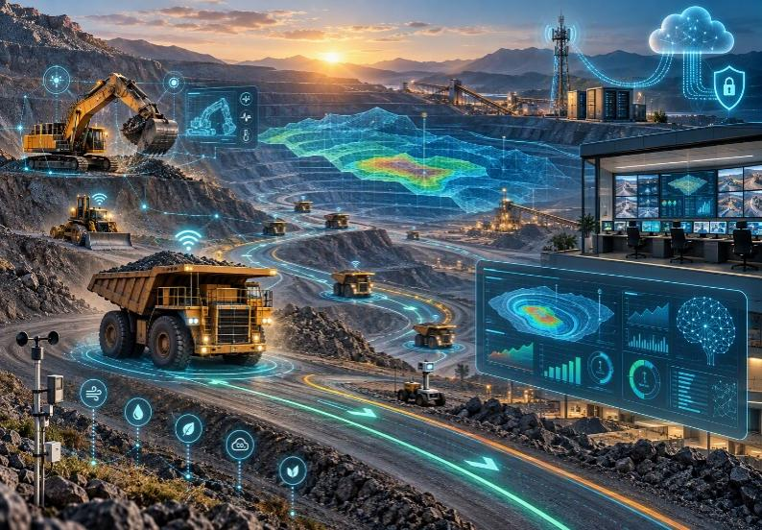
IoT serves as the foundational layer enabling this transformation.
Conclusion
IoT is no longer simply a technology initiative; it is a strategic business capability that enables mining organizations to achieve higher productivity, safer operations, better asset performance, and improved workforce well-being.
The strongest results will come from treating IoT as an enterprise architecture rather than a collection of disconnected pilots. Interoperability, cybersecurity, resilient connectivity, data quality, workforce adoption, and integration with existing operational systems are therefore as important as the sensors themselves.
By integrating real-time traceability, predictive maintenance, intelligent safety systems, and health monitoring capabilities, mining companies can transition from reactive operations to predictive and autonomous decision-making models.
Organizations that successfully deploy IoT across their mining ecosystem will be better positioned to improve operational resilience, reduce costs, enhance ESG performance, and create a safer and more sustainable future for their workforce.
End

