BODY CAMERAS + CCTV - From Surveillance to Situational Intelligence

The Convergence of Fixed and Mobile Video for Safer, Smarter and More Accountable Operations

A Thought-Leadership White Paper

Executive Summary
Fixed CCTV has become an essential component of public safety and security infrastructure. Cities, police organisations, railways, airports, ports, industrial facilities and public-sector organisations increasingly depend on extensive networks of cameras to monitor people, assets and environments.
Yet fixed surveillance has a fundamental limitation: the camera stays where it is while the incident moves.
A confrontation may begin within a camera’s field of view and move elsewhere. A responding officer may enter a crowded area where visibility is obstructed. Important conversations or actions may occur outside the optimal perspective of a fixed camera.
Body-Worn Cameras (BWCs) address this limitation by placing a secure, mobile video and audio sensor directly with the responding personnel.
The opportunity is therefore not to replace CCTV with BWCs, but to combine the strengths of both.
Fixed CCTV provides environmental and wide-area context. BWC provides first-person, close-range evidence. Command-and-control platforms coordinate the response, while Digital Evidence Management Systems preserve and organise the resulting information.
This convergence creates a continuous operational chain:
The result is a more complete and accountable approach to public safety, security and field operations.

The Surveillance Gap
Traditional CCTV systems are designed primarily for persistent observation.
They are highly effective at:
- Monitoring defined locations
- Establishing visual context
- Detecting movement and events
- Supporting investigations after an incident
- Providing historical footage
However, several limitations remain inherent in a fixed-camera architecture.

Limited Perspective
A camera sees from one physical position. Physical interactions may occur outside its field of view or at a distance that reduces useful detail.

Mobility of Incidents
Incidents do not respect camera boundaries. A person can move from a station concourse to a platform, from a public area into a building, or from a monitored zone into an uncovered area.

Crowd and Environmental Obstruction
People, vehicles, infrastructure and environmental conditions can obstruct the view at precisely the moment when detailed evidence is required.

Limited Context
A distant image may show what happened without adequately capturing the interaction, conversation or sequence of events that preceded it.
These limitations do not make CCTV ineffective.
They establish the need for another layer of observation.

Why Are Body-Worn Cameras Different?
A Body-Worn Camera is fundamentally different from a conventional surveillance camera because it is associated with a person, activity and operational response.
Depending on the system and policy, a BWC can provide:
- First-person video
- High-quality local audio
- Pre-event recording
- Location and time information
- Secure wireless transmission
- Local/offline recording
- Incident tagging
- Device and user authentication
- Secure evidence upload
Its greatest advantage is simple: The camera moves with the person responding to the incident.
This makes the BWC particularly valuable for police officers, railway protection personnel, security teams, inspectors, enforcement officers, emergency responders and field technicians.

CCTV + BWC: Complementary Architecture
The strongest deployment model is not either/or.
It is CCTV + BWC + Command + Evidence Management.
Capability | Fixed CCTV | Body-Worn Camera
Coverage | Wide area | Individual / immediate area
Perspective | Environmental | First-person
Mobility | Fixed | Mobile
Incident context | Strong | Strong at point of interaction
Audio | Deployment dependent | Core capability
Field response | Indirect | Direct
Evidence | Historical surveillance | Incident-focused evidence
The two technologies therefore serve different operational purposes.

Fixed CCTV
Observe the environment.

BWC
Document the interaction.

Command Centre
Coordinate the response.

Digital Evidence Platform
Preserve and manage the record.
The combination is significantly more useful than treating each technology as an isolated system.

From Incident Detection to Digital Evidence
An integrated ecosystem of incident lifecycle, color-coded by phase: detection and assessment, response and capture, correlation, evidence management, and investigation and outcomes.
This model is important because video has value only when it can be reliably connected to the event it represents.  An effective system should therefore associate relevant recordings with:  - Incident ID  - Date and time  - Location  - Officer/user  - Device  - Relevant CCTV cameras  - Event classification  - Evidence status  The result is a structured digital incident record, rather than a collection of unrelated video files. | 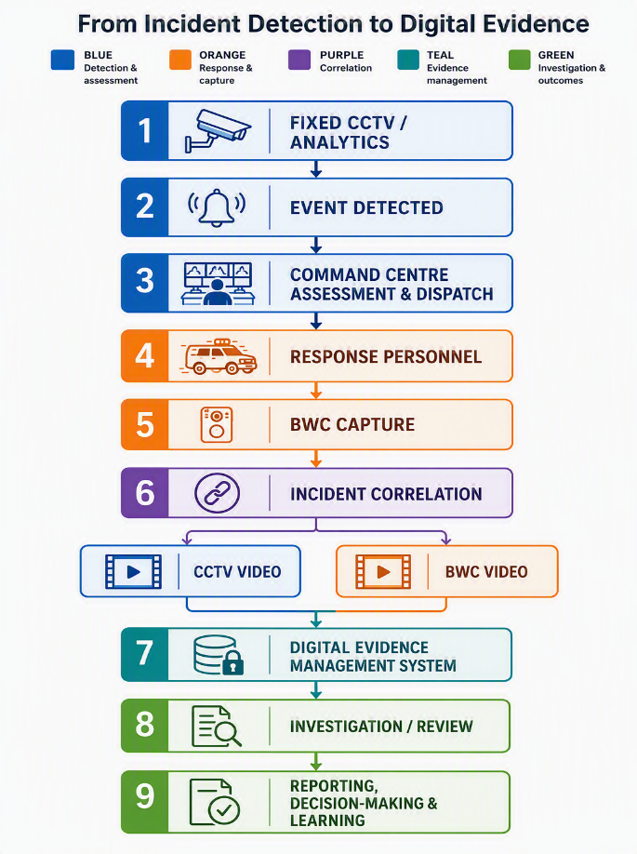

Building a Trusted Evidence Chain
The credibility of digital evidence depends on more than image quality.
Organisations should consider the complete evidence lifecycle:
Capture → Authenticate → Encrypt → Transfer → Store → Audit → Retrieve → Share
Important capabilities include:
- Device and user authentication
- Accurate time synchronisation
- Encryption in transit and at rest
- Evidence integrity mechanisms
- Role-based access
- Immutable or auditable activity logs
- Retention policies
- Controlled evidence export
- Chain-of-custody records
Where supported by the platform, cryptographic hashing can help demonstrate that an evidence file has not been altered after capture or ingestion.
The objective is to provide investigators and authorised stakeholders with confidence in the provenance and integrity of the evidence.

The Role of Pre-Event Recording
Incidents often develop before a BWC is manually activated. A configurable pre-event buffer can preserve the moments immediately before activation—such as the initial interaction, escalation, instructions, movement and preceding actions—helping authorized reviewers understand the event in context. Its duration, audio settings, access, retention and use should be governed by organizational policy, law and privacy requirements so that additional context is captured proportionately rather than indiscriminately.

Stakeholder Value
Pre-event recording and integrated video deliver distinct but complementary value across the stakeholder groups involved in governance, operations, investigations and public accountability.
Stakeholder value from pre-event recording and integrated video
Stakeholder | Primary value | Operational and governance outcomes
Government and Municipal Authorities | Improved public safety oversight and evidence-led governance. | Transparent enforcement; faster emergency response; regulatory compliance; operational performance analysis; better visibility of incident locations and resource use.
Law Enforcement and Security Organizations’ | Reliable first-person evidence with context before manual activation. | Objective supervisory review; correlation of CCTV and BWC viewpoints; structured evidence retrieval; operational training; evidence-based review of complaints and disputed incidents.
Public Sector Undertakings | Mobile evidence across distributed or partially covered infrastructure. | Asset protection; security patrols; inspections; maintenance documentation; contractor monitoring; safety compliance; emergency response; incident investigation where fixed coverage is impractical.
Officers and Field Personnel | An objective record that supports both accountability and personnel protection. | Documentation of interactions; evidence in disputed incidents; personal-safety support; reduced uncertainty during reviews; demonstrable compliance with procedures.
Citizens and Communities | Greater transparency and confidence in public-authority interactions. | More credible investigations; better dispute resolution; transparent enforcement; safeguards against inappropriate behaviour; faster incident reconstruction, subject to clear legal, privacy and retention controls.

Priority Use Cases
Priority deployments focus on mobile personnel working in environments where fixed surveillance cannot fully capture interactions, movement or field conditions.
Environment | Priority use cases | Primary value
Law Enforcement | Patrols, traffic enforcement, crowd and demonstration management, arrests, incident response and evidence collection. | Documents public interactions and supports accountable enforcement and investigation.
Railways and Metro | Security patrols, station and platform incidents, passenger interactions, yards, tracks, emergencies and asset protection. | Extends evidence coverage across moving, crowded and distributed transport environments.
Airports and Ports | Patrols, restricted-area monitoring, passenger interactions, incident response and compliance inspections. | Strengthens controlled-area security, response documentation and regulatory assurance.
Mining and Industrial Facilities | Safety and remote-asset inspections, perimeter patrols, contractor compliance and emergency response. | Provides a verifiable field record in hazardous, remote and partially monitored locations.
Municipal Services | Enforcement, field inspections, emergency services, public-space management and regulatory operations. | Improves transparency, service accountability and evidence-based resolution of field events.
The common denominator is the presence of mobile personnel operating in environments where fixed surveillance provides incomplete coverage.

From Intelligent Integration to Evidence-Led Public Safety
The following overview shows how connected video operations develop into a secure, governed and measurable evidence-intelligence capability.
Focus | Summary
Intelligent Integration | Connects CCTV, BWCs, command and control, incident management, GIS, analytics, identity, evidence management and reporting into one operational chain from detection and dispatch to capture, correlation, preservation and investigation.
AI and Analytics | Improves video search, classification and prioritization through detection, transcription, metadata, redaction and summarization, while keeping human judgement central to consequential decisions.
Cybersecurity and Data Protection | Protects devices, networks, data and platforms through trusted identity and firmware, encryption, secure transfer and storage, access controls, audit logs, monitoring, retention controls and vulnerability management.
Privacy and Responsible Use | Requires proportionate rules for activation, pre-event capture, sensitive locations, access, retention, sharing, redaction, deletion and audit, limiting collection and use to what is necessary and lawful.
Implementation Framework | Starts with operational needs: define the problem, select high-value use cases, assess existing infrastructure, establish governance, run an outcome-focused pilot, and scale through integration and measurable results.
Measuring Success | Uses outcome-based measures such as response and resolution times, policy compliance, evidence-processing speed, investigation turnaround, audit exceptions, retention compliance, training, complaint resolution, personnel safety and avoidable errors.
Evidence-Led Public Safety | Describes the progression from standalone recording to connected systems and evidence intelligence, where trusted video is detected, correlated, analysed, preserved and converted into knowledge that supports decisions, accountability and learning.
Taken together, these themes preserve the original sequence: integrate operational systems, apply analytics with human oversight, secure the evidence lifecycle, govern privacy and use, implement through controlled pilots, measure outcomes, and mature toward evidence-led public safety.

The Strategic Opportunity
For governments, police organizations and public-sector undertakings, integrated CCTV, BWCs and digital evidence platforms can support safety, compliance, investigations, asset protection, training, risk management, emergency response and institutional accountability. The strategic opportunity is to treat BWCs as part of a broader physical-security and digital-evidence ecosystem rather than as standalone devices.

Conclusion
Fixed CCTV and BWCs are complementary: CCTV provides environmental context, BWCs capture close-range interactions, command systems coordinate response, AI assists analysis, and digital evidence management preserves and governs the record. Integrated as one operational chain—from detection and response through capture, correlation, evidence, investigation and learning—these capabilities enable more responsive public safety, stronger infrastructure protection, efficient investigations and greater transparency.

